The focus of our data exploration for project 1 was global deforestation, with a deeper dive in to South American countries, exploring reforestation and subsequent increase in biodiversity following reforestation efforts.

The questions that we asked of our data were as follows; which continents are leading with deforestation globally, what are the deforestation and reforestation rates in South America, and what are the main drivers of deforestation in Brazil.

Which continents are leading with deforestation globally?
In the period from 1990 to 2020, our data shows that South America and Africa are clearing forest at a faster rate than the other continents, clearing roughly 2MHa each in the time period.

We analysed data from Asia, Europe, Oceania and North America, which have all shown net growth in total forest size over the same period.

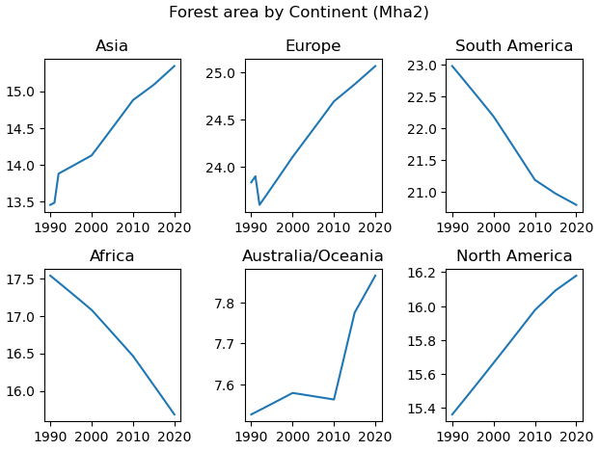

What are the deforestation and reforestation rates in South America?
We explored the net forest conversion in hectares over a period of 25 years in South America. A negative value means that the country cut down more trees than it planted. We observed that Brazil had a much higher rate of deforestation compared to the other South American countries, and as such had to convert our y axis to a log format to be able to view the data properly on the graph due to the big difference in values for Brazil. After the year 2000, Brazil started to decrease their rates of deforestation, however up until 2015 the country was still cutting down more trees than what it was planting as shown below.

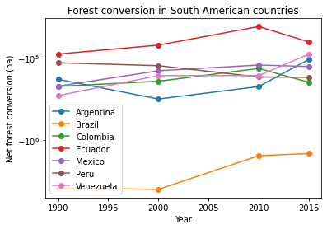

Data gathered for reforestation rates is graphed below, showing that South American countries are lead by Costa Rica for hectares of forest replanted in the year studied.
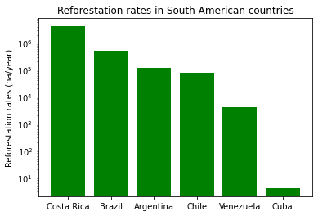

Afforestation by land size is led by Peru in South America, however comparative analysis showing re- and afforestation as a percentage of land size would present a more subjective review of the data found.

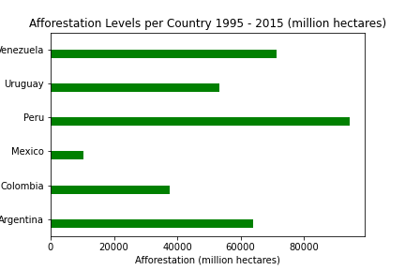

Taking a further look at the total forest size of Brazil, we produced the bellowing graph. Which shows a dramatic rate of deforestation in Brazil from the year 1990 to 2016. Further research in to the reason behind the high growth in forest size in 2017 is necessary as this data set does not give reasons or explanation for the near restorative rate of growth in only 12 months.

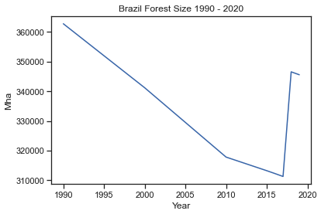

What are the main drivers for deforestation in Brazil?
Brazil’s deforestation has many drivers; however the leader is clearing land for pasture – that is clearing for farming and grazing of animals. Also notable in the early to mid 2000s was clearing for commercial crops.

Small scale clearing, fire and selective logging were also notable. Mining, clearing for infrastructure and natural disturbances were smaller contributors (not graphed).

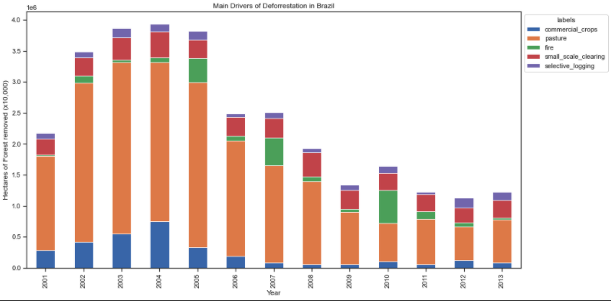

We noted the shape of the above graph, with clearing practices seeming to drop off and stabilise from 2006 onwards and decided to investigate other datasets to see if this held true. We found that data showed a decline in the rate of deforestation for use as cropland, agriculture and arable land from the early 2000s through to 2020.

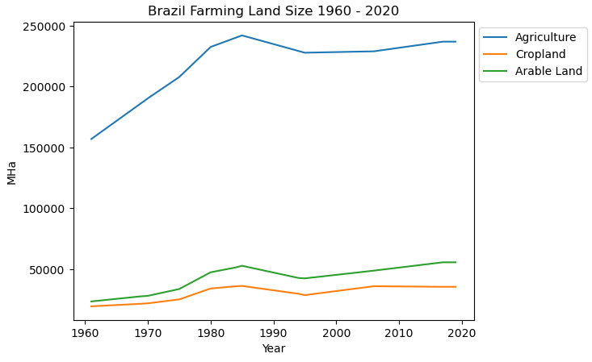

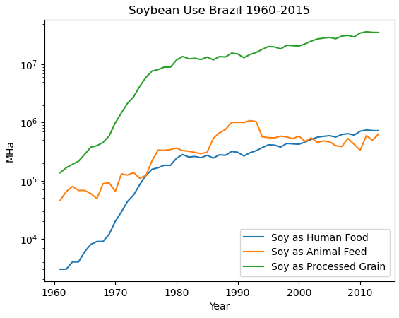

This correlates with the graph above on the use of soybean crops in Brazil. As illustrated total usage began to stabilise around 1990 and further plateaued in the mid 2000s. Our assumption with this data is that the land already cleared for soybean farming was cleared by this point.

Further data exploration would be needed to investigate this hypothesis.

Finally, we chose to look at the rate at which Brazil was reforesting their land and found a promising increase in planted forest size from 2000 to 2020. The rate at which forests are being replanted, however, is much less than the rate at which deforestation is occurring however, and the net forest conversion remains a negative – meaning the total forest size continues to decline in Brazil.

Limitations of the data:
While we were able to draw initial conclusions on deforestation rates and subsequent reforestation efforts, there is a lot more data that can be analysed in greater detail in order to determine the true drivers and effectiveness of reforestation programs as well as drivers of deforestation globally.
